***NAME : Himanshu Dixit***

***ENROLL NO. : B64178***

***BATCH : B10***

***SOFTWARE DEVELOPMENT FUNDAMENTAL LAB-I(15B17CI171) Lab Test (PHASE-2)***

***Lab B***

***1. Solution :***

#include<stdio.h>

int main()

{

int select,q;

printf("MENU CARD\nSelect your drink\n");

printf("1. Banana Shake(Rs 20)\n2.Mango Shake Shake(Rs 50)\n3. Chocolate Shake(Rs 60)\n4. Vnilla Shake(Rs 40)\n");

scanf("%d",&select);

switch(select)

{

case 1:printf("You have selected : Banana Shake\n");

printf("Enter the quantity : ");

scanf("%d",&q);

printf("Total amount : %d",q*20);

break;

case 2:printf("You have selected : Mango Shake\n");

printf("Enter the quantity : ");

scanf("%d",&q);

printf("Total amount : %d",q*50);

break;

case 3:printf("You have selected : Chocolate Shake\n");

printf("Enter the quantity : ");

scanf("%d",&q);

printf("Total amount : %d",q*60);

break;

case 4:printf("You have selected : Vnilla Shake\n");

printf("Enter the quantity : ");

scanf("%d",&q);

printf("Total amount : %d",q*40);

break;

default:printf("Sorry Unavailable");

}

return 0;

}

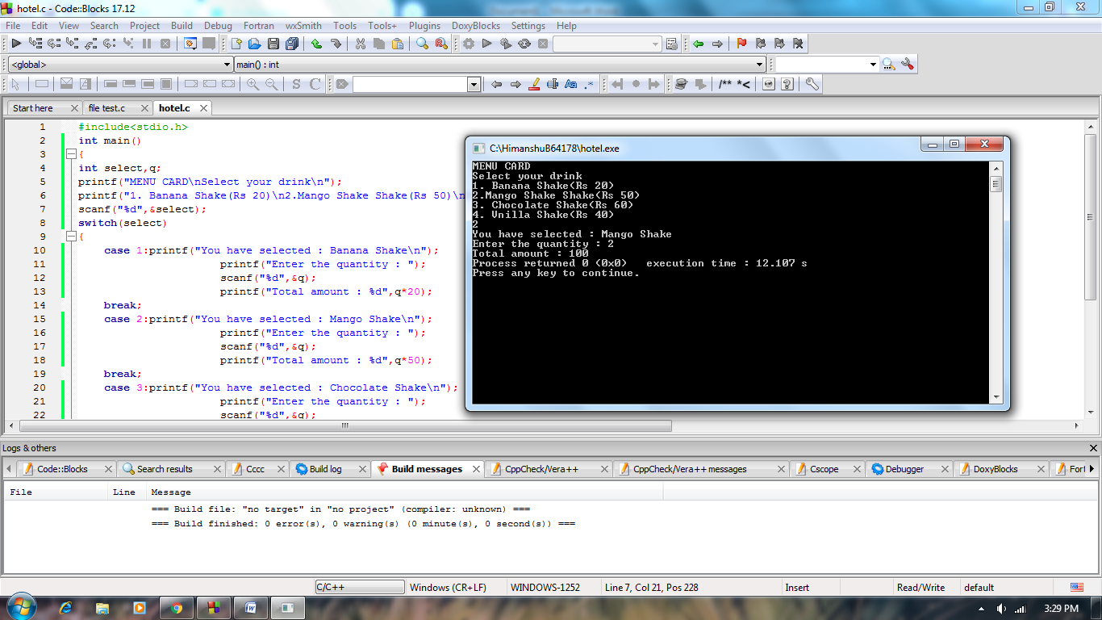

***2. Solution :***

#include<stdio.h>

int main(){

for (int i =0 ; i <= 5; i++)

{

for (int j = 0; j < i; j++)

{

printf(" ");

}

for (int j = 0; j < 3; j++)

{

printf("*");

}

for (int j = 0; j <= 4-i; j++)

{

printf(" ");

}

for (int j = 0; j < 3; j++)

{

printf("*");

}

for (int j = 0; j <= i-1; j++)

{

printf(" ");

}

for (int j = 0; j < 3; j++)

{

printf("*");

}

for (int j = 0; j <= 4-i; j++)

{

printf(" ");

}

for (int j = 0; j < 3; j++)

{

printf("*");

}

printf("\n");

}

return 0;

}

